
Land Information Ontario (LIO) Warehouse
Data Class Name: Fisheries Management Zone
Documentation
Produced by: Information Access and Information Management Policy Unit
Ministry of Natural Resources and Forestry
Date: July 27, 2015

Purpose

This document provides additional information to support the use of geospatial data. The Physical Model Diagram provides a visual representation of the relationships in the data class. The Data Change History lists all the modelling and access changes that have occurred during the lifecycle of the data class. A data description identifying table and field names is available upon request.

Need Assistance?
Please contact LIO Support at lio@ontario.ca or 705-755-1878 if you require help.

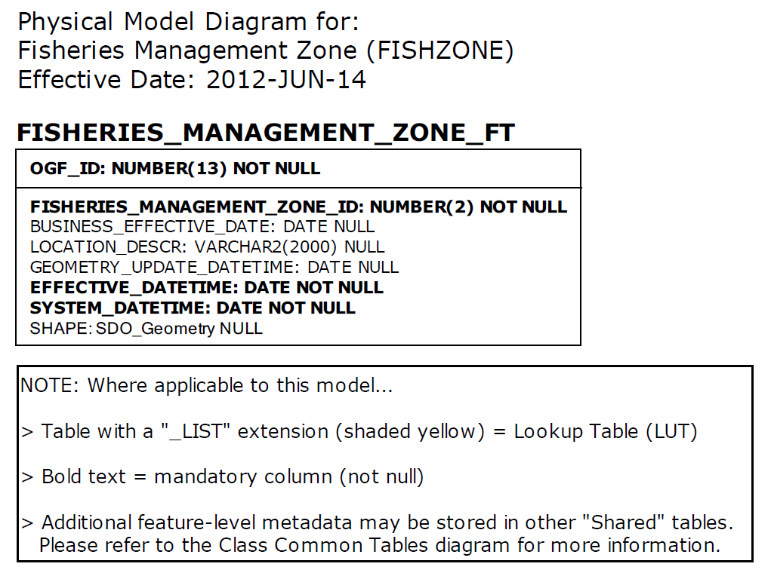

Data Class Change History

Data Class Name: Fisheries Management Zone
Data Class Short Name: FISHZONE
Date  YYYY-MM-DD | Details of Change
2011-01-14 | FISHERIES_MANAGEMENT_ZONE_FT.LOCATION_DESCR Column addedto enable the client to capture a textural description of the Fisheries Management Zone.
2011-01-14 | GEOG_UNIT table and associated tables dropped to change to simple data class.
2011-01-14 | Column added: FISHERIES_MANAGEMENT_ZONE_FT.BUSINESS_EFFECTIVE_DATE  The Business Effective Date field was originally found in the GEOGRAPHIC UNIT table however it has been moved into the feature class table. This field will allow users to determine the date for the Fisheries Management Zone boundary.
2006 | NEW Data Class
Data Description
Please refer to the metadata record for the data description.

